Newburgh United Methodist Church Recreation Ministry

2019 PICKLEBALL for TURKEYS
Adult CO-ED Tournament

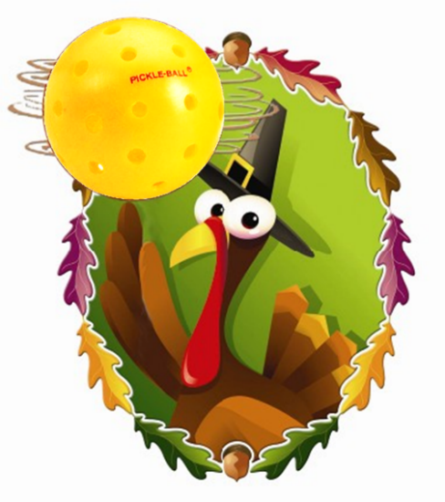

Proceeds go toward Thanksgiving baskets for our food pantry families!

PICKLEBALL SKILLS
Please rate your pickleball skill level:

____ Beginning Pickleball: New to Pickleball or limited experience. Forehand, backhand, and rallying need development but you love to try! You may or may not know game rules.
_____Advanced Pickleball: You are an experienced player. You can serve, spin, and rally the ball consistently.

DEADLINE to REGISTER is November 10th, 2019

- Mixed Doubles
Saturday, November 16 9:00AM $25 per player
- Ages 14+
- Sign up with a partner or by yourself and we will assign you a partner
- The brackets will be emailed by Wed. Nov 13th

Please turn in this completed form, along with $25, to the church office by Nov 10th.

Make checks payable to “Newburgh UMC” and in the note area write “Pickleball Tourney”.
Mail to: Newburgh UMC
4178 Highway 261 Newburgh, IN 47630

Name ___________________________________________

Partner’s name ___________________________________

Email ___________________________________________

Phone ___________________________________________

Contact Angie Barr for more information at
angie@newburghumc.org.

And whatever you do, whether in word or deed, do it all in the
name of the Lord Jesus…Colossians 3:17

